**HEART RATE MONITORING DEVICE USING NODEMCU AND THINGSPEAK**

**INTRODUCTION:**

Heart is one of the most important organs of human body. Monitoring heart rate is a vital aspect of maintaining heart health. Many people suffer sudden heart attack and irregular heart rate without them knowing. By monitoring the heart rate, we can prevent us from many issues and by storing these data’s, we can use it in the future to find the cause of irregularity in heart rate. In hospitals, patients heart rate and other features are measured using a patient monitor which is larger in size and costlier and the nurse need to check the monitor often to know the heart rate of the patient. In this project, we propose an advanced IoT bases heart rate monitoring device which measures the heart rate and sends the values to a web server.

**IoT BASED HEART RATE MONITORING DEVICE:**

This project is simply a miniaturized heart rate monitoring device which continuously monitor the users heart rate and the collected information is send to a web server using a microcontroller. The information of the individual can be viewed by a doctor or a head nurse from anywhere. This solves the problem of the nurses where they need to check the patient’s heart beat for every hour. This project simply uses a pulse sensor to measure the heart rate. The measured information is sent to the microcontroller where the information is processed and converted into signal. The processed signal is sent to the webserver for future purposes.

**WORKING:**

Pulse rate Sensor is a well-designed plug-and-play heart-rate sensor for Arduino. The heart rate sensor measures your heart rate in Beats per Minute using an optical LED light source and an LED light sensor. The light shines through your skin, and the sensor measures the amount of light that reflects back. The light reflections will vary as blood pulses under your skin past the light. The measured value is sent to NodeMCU. The NodeMCU is and open-source software and hardware development environment build around an inexpensive System-on-a-chip (SoC) called the ESP8266. The ESP8266 contains the crucial elements of a computer: CPU, RAM, networking (Wi-Fi), and even a modern operating system and SDK. That makes it an excellent choice for the Internet of Things projects of all kinds. To access and use the ESP8266, you must solder wires, with the appropriate analog voltage, to its pins and also have to program it in low-level machine instructions that can interpreted by the chip hardware.

The software implementation for this project is made with ThingSpeak software. ThingSpeak is an Internet of Things (IoT) platform that lets you collect and store sensor data in the cloud and develop IoT applications. The ThingSpeak IoT platform provides apps that let you analyze and visualize your data in MATLAB, and then act on the data. It has built-in web app and mobile app for immediate use. The ESP8266 will connect the network of your router that you will provide in the code and will send the data of the sensor online. This data on the ThingSpeak will be shown in a Graph form showing the past readings too and can be accessed from anywhere over internet.

**CIRCUIT DIAGRAM:**

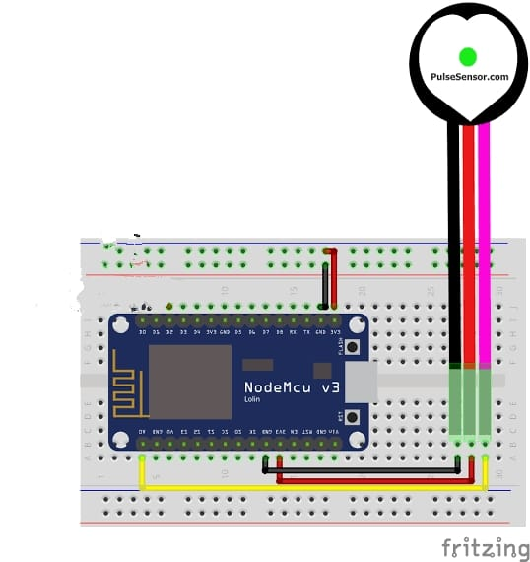

**PROJECT IMAGES:**

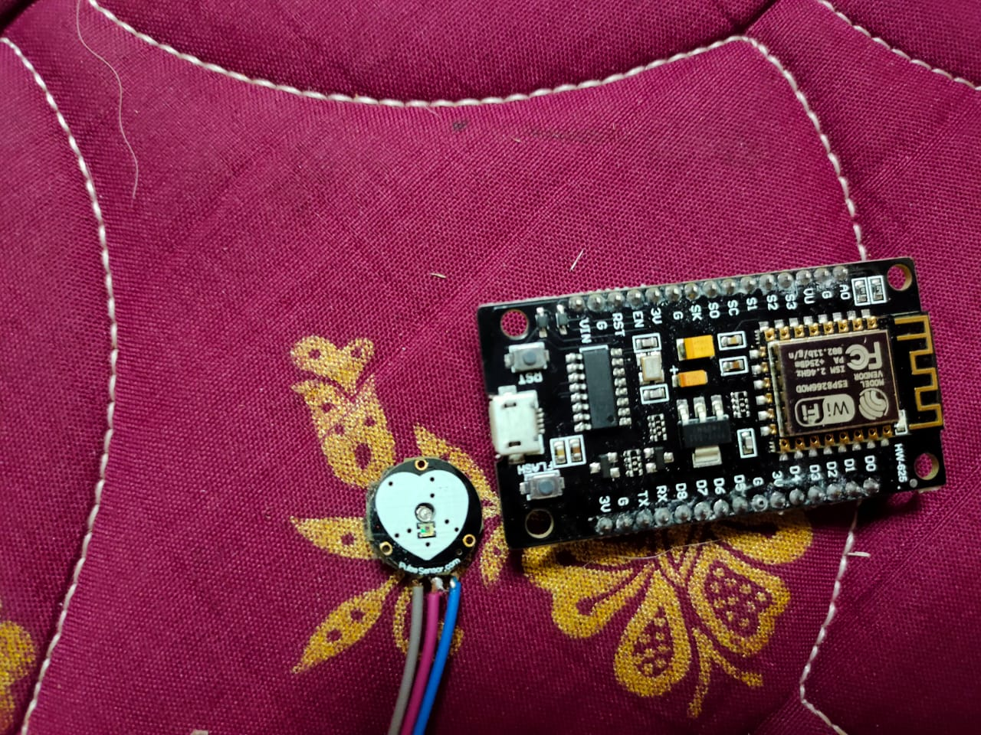

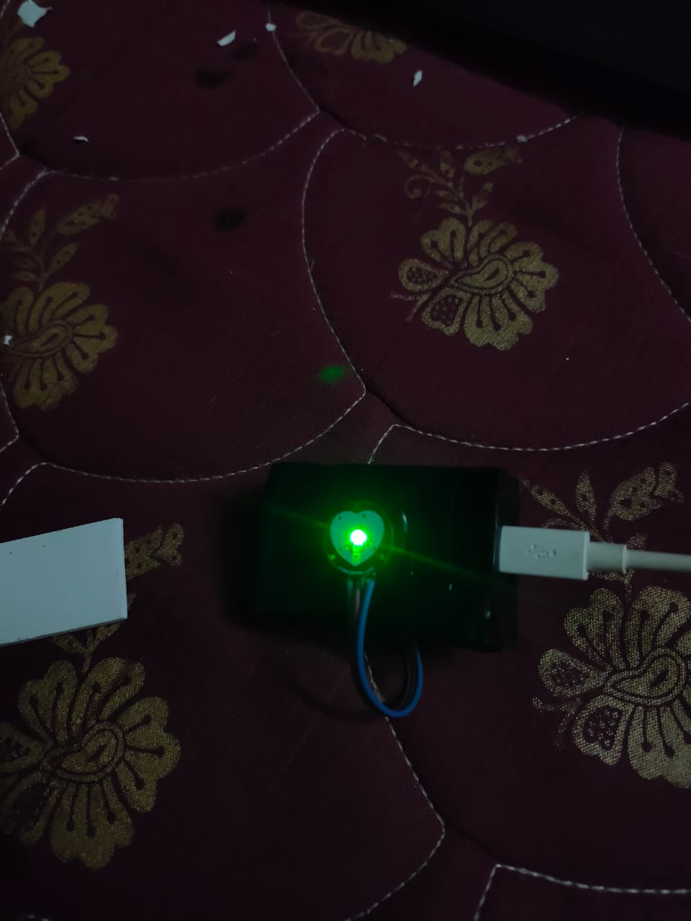

**RESULT:**

This project reduces the time required for setting up a patient monitor and measuring the heart rate and also saves the data’s in the server where it can be viewed anytime which is useful in future for determining the cause and time of heart attack or irregularities.